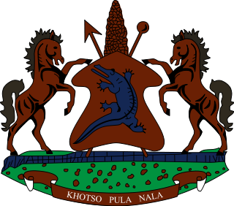

**INTERVENTION OF THE DELEGATION OF OF LESOTHO DURING THE 4th UPR CYCLE OF CAMEROON**

**14 NOVEMNER 2023**

**GENEVA, SWITZERLAND**

Thank you Madam vice President,

Lesotho welcomes the distinguished delegation of Cameroon to the 4th UPR. We recognise the notable efforts made by Cameroon, to safeguard the rights of persons with disabilities, by ratifying both the AU and UN treaties on the Rights of Persons with Disabilities. We note with appreciation the measures undertaken to improve the right to education, particularly of children from disadvantaged backgrounds.

Despite the positive developments made, Lesotho wishes to make the following 3 recommendations for consideration by Cameroon 1. To scale up efforts to ensure the full respect of the freedom of expression, association and assembly, by the security forces; 2. To continue to bolster efforts to alleviate the plight of diseases such as, HIV, Malaria and Cholera; and lastly, to undertake measures to popularise laws prohibiting marriage of children under the age of 18.

Finally, we wish Cameroon every success with this UPR cycle

THANK YOU