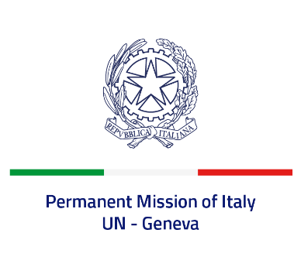

*Check against delivery*

**UPR 44 - Cameroon**

**Tuesday 14 November 2023, 14:30 - 18:00**

**Delivered by: Ambassador Vincenzo Grassi, Permanent Representative of Italy**

*(Focal point: Angela Zanca, First Secretary)*

Thank you, Mister President.

We thank the distinguished delegation of Cameroon for the presentation.

Italy welcomes the ratification of the Convention on the Rights of Persons with Disabilities and the Optional Protocol to the Convention on the Rights of the Child on the Sale of Children, Child Prostitution and Child Pornography.

We also look forward to the deposit of ratification instruments for the Optional Protocol to the Convention against Torture, signed in 2009.

Italy seizes this opportunity to offer Cameroon the following recommendations:

•        *Consider ratifying the Second Optional Protocol to the International Covenant on Civil and Political Rights, with a view to fully abolishing the death penalty;*

•        *Take appropriate measures to align the condition of detainees with international standards;*

•        *Strengthen its efforts to effectively guarantee full enjoyment of human rights for children, women and other vulnerable groups.*

We wish Cameroon a successful review.

I thank you.