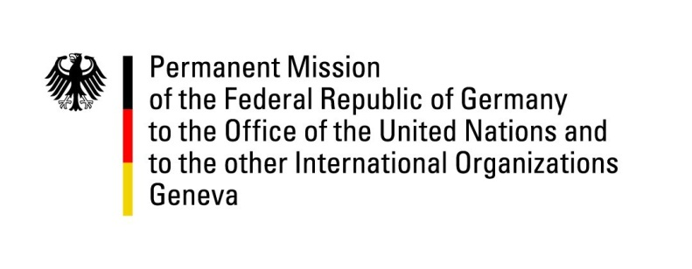

**United Nations Human Rights Council**

**44th Session of the UPR Working Group**

**Geneva, 14th of November 2023**

**German Recommendations and advance questions to**

**Cameroon**

Mister President,

Germany welcomes the delegation of Cameroon and commends the country for starting a process towards accountability for human rights violations committed by members of the armed forces.

However, Germany remains deeply worried by the overall human rights situation especially with regard to the situation in internal conflict zones. Attacks on civilian infrastructure and most of all, the accounts of sexual and gender-based violence are cause for grave concern. Furthermore, the situation in institutions of law enforcement such as prisons and jails has not improved since Cameroon’s last UPR review. More work is needed to ensure accountability for human rights violations by law enforcement and security forces.

Germany therefore recommends Cameroon to:

* Take decisive steps to improve conditions in prisons and jails,
* Combat sexual and gender-based violence, especially in conflict zones, and implement concrete steps to prevent domestic violence
* Strengthen the role of women in society, also through information concerning FGM and other damaging practices, bolster girls’ education, and present measures to include women in the workforce, and
* Fully ratify the Statute of Rome, to which it is a signatory.

Thank you, Mister President.