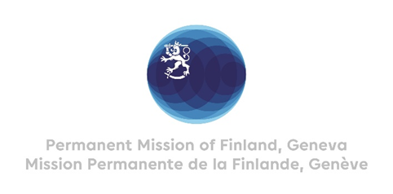

44 Session of the UPR working group Recommendations by Finland to Cameroon

14th November 2023

Thank you Mr. President,

Finland appreciates the engagement of Cameroon in the UPR process and the comprehensive report presented.

Finland wishes to make the following recommendations:

- First, to consider ratifying the Optional Protocol of the Convention against Torture.
- Second, to consider signing and ratifying the Second Optional Protocol to the International Covenant on Civil and Political Rights aiming to the abolition of the death penalty.
- Third, to consider ratifying the Convention for the Protection of All Persons from Enforced Disappearance.

Finland wishes Cameroon every success with the follow up and implementation of the recommendations received during this fourth cycle of the UPR process.

I thank you.

