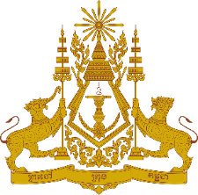

**PERMANENT MISSION OF THE KINGDOM OF CAMBODIA**

**TO THE UNITED NATIONS AT GENEVA**

**Statement of Cambodia**

At the 44th Session of the UPR Working Group

UPR of the Republic of Cameroon

14 November 2023

-------

Mr. President!

1. Cambodia welcomes the delegation of the Republic of Cameroon and thanks for the presentation of its national report.
2. We commend efforts taken by the government of the Republic of Cameroon in promoting and protecting the economic and social rights of vulnerable groups including women, children, and persons with disabilities.
3. In the constructive spirit, Cambodia would like to put forward following recommendations:

* Continue its efforts to implement effective measures to further preventing child abuse including forced marriage and recruitment into armed groups;
* Continue its engagement with human rights mechanisms to further promote and protect the rights of its people.

1. Finally, I wish the delegation of the Republic of Cameroon every success in this review.

Thank you!

*\*\*\*\*\**