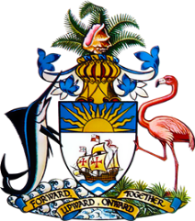

**Statement by Second Secretary Mr. Charles Gibson of the Permanent Mission of The Bahamas to the United Nations Office and other International Organizations in Geneva**

**at the 44th Session of the Universal Periodic Review Working Group**

***Presentation of UPR Report by the Government of Cameroon* 14 November 2023**

Thank you, Mr. President/Vice-President,

The Bahamas thanks the delegation of Cameroon for its report and commends progress made since the last review.

Cameroon demonstrates its commitment to human rights with strong legal protections and freedoms for activists, and through initiatives like the Far North Region Reconstruction Plan, emphasizing rebuilding and sustainable, climate-adaptive development.

We commend Cameroon’s efforts toward implementation of recommendations emanating from the Human Rights Committee and the Working Group on Arbitrary Detention.

In a constructive spirit, The Bahamas recommends that Cameroon:

1. Strengthen efforts to conserve ecosystems, including forests and rivers, to support biodiversity and community livelihoods
2. Work with local communities, especially those affected by climate change, to create adaptive strategies and enhance resilience
3. Launch extensive campaigns to educate the public on preventive healthcare, nutrition, hygiene, and disease prevention.

We wish Cameroon a successful UPR. I thank you.

Speaking time 1 minute 5 seconds