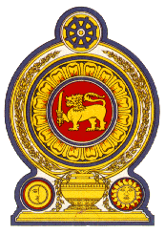

**44th Session of the Universal Periodic Review**

**Review of Burkina Faso**

**06 November 2023**

**Statement by the Democratic Socialist Republic of Sri Lanka**

Mr President,

Sri Lanka thanks the delegation of Burkina Faso for their presentation.

We commend Burkina Faso’s progress since its last UPR. Sri Lanka notes with appreciation the public policies and institutional frameworks which were developed and implemented, to promote the enjoyment of human rights notably, the National Security Policy 2020–2050 and Sectoral Policy on Justice and Human Rights 2018–2027.

In a constructive spirit, Sri Lanka recommends that Burkina Faso:

-Promotes the rights of the child by ensuring their safety and access to education.

-Ensure protection of women from exploitation, harassment and gender-based violence.

We wish Burkina Faso success in its UPR engagement.