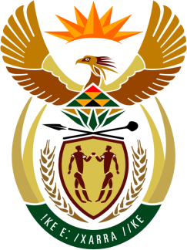

**SOUTH AFRICAN PERMANENT MISSION**

**TO THE UNITED NATIONS**

**AND OTHER INTERNATIONAL ORGANISATIONS**

**44th SESSION OF THE WORKING GROUP ON THE**

**UNIVERSAL PERIODIC REVIEW**

**Review of BURKINA FASO**

**06 NoveMBer 2023**

**(70 Seconds)**

**speaker no:21**

***Check against delivery.***

Mr./Ms President, Vice President

South Africa welcomes the distinguished delegation of Burkina Faso to this UPR Session and wishes the country a successful review.

South Africa wishes to make the following recommendations:

* Ratify the Optional Protocol the International Covenant on Economic, Social and Cultural Rights,
* Implement the ICPD25 commitment to harness the demographic dividend, particularly on young people, to accelerate economic growth and sustainable human development by promoting decent employment and social protection for all,
* Implement a strategy to guarantee the sexual and reproductive health and rights of young people by combating female genital mutilation and child marriage and reducing maternal mortality linked to unsafe abortions,
* Accelerate the adoption of a new Code of Persons and Family, repeal all discriminatory provisions against women and raise the minimum legal age of marriage to 18 years old for both men and women, without exception.

In conclusion, we commend Burkina Faso for the strides made since its last review and welcome inter alia the ratification of the African Charter on the Values and Principles of Decentralization, Local Governance and Local Development.

I thank you