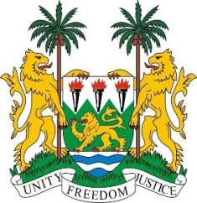

**SIERRA LEONE**

**44th Session of the UPR**

**BURKINA FASO**

Monday, November 6th, 2023

**Mr. President**,

Sierra Leone welcomes **H.E. Mr. Edasso Rodrigue BAYALA, Minister of Justice and Human Rights, in charge of relations with institutions** and the distinguished delegation from Burkina Faso and thanks it for the presentation of its national report.

Sierra Leone welcomes the measures taken to promote the protection of human rights, including the adoption of several laws and national action plans, in particular the Human Rights Council Resolution A/HRC/RES/44/16, adopted 17 July 2020, on combatting FGM.

In a spirit of constructive engagement, we recommend the following for the Burkina Faso`s consideration:

1. Promote the full exercise of the rights to freedom of expression and assembly, including in the context of security measures.
2. Strengthen efforts to combat gender-based discrimination and violence, especially through enforcement of laws.
3. Consider ratification of the Optional Protocol to the ICESCR, with a view to ensuring the fulfilment of economic, social, and cultural rights.
4. Consider ratifying the Second Optional Protocol to the ICCPR aiming at the abolition of the death penalty.

Sierra Leone wishes Burkina Faso every success in the completion of its fourth review cycle.

Thank you, Mr. President,