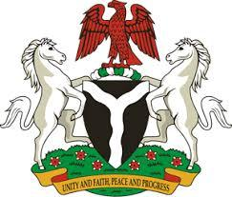

*Please check against delivery*

**HUMAN RIGHTS COUNCIL**

**44TH SESSION OF THE WORKING GROUP OF THE UPR OF THE REPUBLIC OF BURKINA FASO**

**STATEMENT BY NIGERIA**

**6TH NOVEMBER, 2023**

**Mr. President**,

Nigeria warmly welcomes the delegation of the brotherly nation of Burkina Faso to the presentation of its National Report and commends the Government for its efforts to promote and protect the rights and fundamental freedoms of the people, despite the security, health and humanitarian challenges.

2. We further commend the demonstrable commitment of the Government of Burkina Faso to improve the socio-economic well-being of its people; in particular, the two Memoranda of Understanding it signed with Nigeria in 2021 on the “Promotion and empowerment of women, gender equality and child protection”, as well as on the “Prevention, suppression and punishment of trafficking in persons, especially women and children”.

3. While acknowledging these spirited efforts by Burkina Faso and cognizant of the need for improvement, Nigeria wishes to, in the spirit of constructive dialogue, recommend the following:

1. To strengthen efforts towards mobilising resources and seeking necessary international support to improve the capacity of its national mechanism for the prevention of torture; and
2. To scale-up investments to improve the socio-economic wellbeing of the people, and ensure the protection of the rights of persons in vulnerable situations.

4. To conclude, we wish Niger every success in its review process.

I thank you.

******