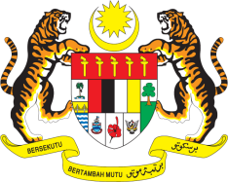

**STATEMENT BY MALAYSIA**

**REVIEW OF BURKINA FASO**

**44TH SESSION OF THE UPR WORKING GROUP**

**6-17 NOVEMBER 2023**

Malaysia commends Burkina Faso’s long-standing commitment to the promotion of human rights.

3. Malaysia takes note of Burkina Faso’s efforts to empower women and girls through the implementation of concrete actions at all levels. However, we are concerned with reports that women and girls are subjected to gender-based discriminatory practices.

4. In the spirit of constructive engagement, Malaysia **recommends** that Burkina Faso:

4.1 Review the National Strategy for the Acceleration of Girls’ Education to ensure equitable access to education for girls and establish an education system free from all forms of discrimination;

4.2 Strengthen the implementation of the National Strategy on Gender 2020–2024, by raising awareness on women’s rights in rural settings and villages through media and education campaigns; and

4.3 Develop a national action plan to provide opportunities for women to become entrepreneurs, improve women's access to decent work, better pay, social protection and quality childcare.

5. We wish Burkina Faso a successful review.

Thank you.

**6 NOVEMBER 2023**

**GENEVA**