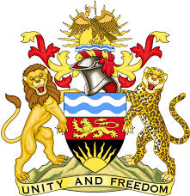

**REPUBLIC OF MALAWI**

**MALAWI STATEMENT ON THE REPUBLIC OF BURKINA FASO UNIVERSAL PERIODIC REVIEW**

**6TH NOVEMBER 2023**

**Mr. President**,

Malawi welcomes the Republic of Burkina Faso to this review and thanks the delegation for the comprehensive presentation.

We commend Burkina Faso’s recent progress in the promotion and protection of human rights which includes: ratification of various treaties, the harmonization of the criminal code with the Convention against Torture; and the improvement of gender equality through the promotion of women's representation in politics and in government ministries, departments, and agencies.

In the spirit of constructive dialogue, Malawi makes the following recommendations to the Republic of Burkina Faso:

1. *Conclude the process of adoption of Child Protection Code;*
2. *Continue with efforts against the practice of female genital mutilation.*

We wish the Republic of Burkina Faso all the best at this review.

**Thank you, Mr. President**.