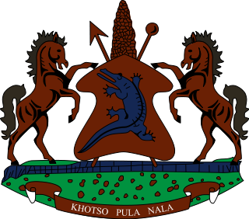

**INTERVENTION OF THE DELEGATION OF LESOTHO UNDER THE 4th UPR REVIEW OF BURKINA FASO**

**06 NOVEMNER 2023**

**GENEVA, SWITZERLAND**

**Thank you Mr. President,**

Lesotho welcomes the distinguished delegation of Burkina Faso to the 4th cycle of their UPR review. We commend Burkina Faso for taking positive steps to inculcate human rights in the country by developing and implementing policies that strengthen the effective enjoyment of human rights of the people of Burkina Faso.

The above notwithstanding, Lesotho wishes to make the following 3 recommendations for consideration by Burkina Faso. 1. To bolster efforts, to find a lasting solution to the issue of FGM, which continue to persist, despite efforts by the government to address the situation; 2. To continue efforts to address overcrowding in places of detention, as well as improving the food and health conditions of inmates; and lastly, to strengthen measures to combat harmful cultural practices and stigmatisation, that hamper full access to health care services, particularly, sexual and reproductive health care for adolescent girls.

Finally, we wish Burkina Faso every success with this UPR cycle.

**THANK YOU**