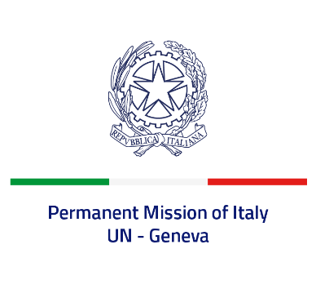

*Check against delivery*

**UPR 44 – Burkina Faso**

**Monday 06 November 2023, 14:30 – 18:00**

**Delivered by: Ambassador Vincenzo Grassi, Permanent Representative of Italy**

*(Focal point: Andrea Lacroce, Second Secretary)*

Thank you, Mister President.

We thank the distinguished delegation of Burkina Faso for their national report and presentation.

Italy welcomes the signing in September 2022 of a memorandum of understanding between the United Nations and the Government of Burkina Faso on the transfer and care of children encountered during security operations.

Nonetheless, we remain deeply concerned by the worsening security crisis and the deterioration of the human rights and humanitarian situation in the country.

Italy seizes this opportunity to offer Burkina Faso the following recommendations:

*• Encourage dialogue, national reconciliation and social cohesion.*

*• Ensure freedom of expression and media freedom.*

*• Strengthen the independence of the judicial system and put an end to arbitrary arrests.*

*• Strengthen efforts aimed at protecting children from the consequences of armed conflict and promoting children's rights, with a focus on the right to education and the fight against child labour.*

*• Promote the adoption of measures to protect women's rights and intensify efforts to combat child early and forced marriages and early pregnancies.*

We wish the delegation of Burkina Faso a successful review.

I thank you.