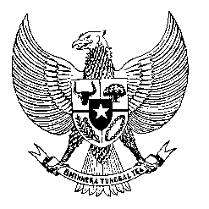

Permanent Mission

of the Republic of Indonesia to the UN, WTO,

and Other International Organizations

in Geneva

**STATEMENT BY THE DELEGATION OF THE REPUBLIC OF INDONESIA**

**AT THE 44th SESSION OF THE UPR WORKING GROUP**

**CONSIDERATION OF THE UPR REPORT OF BURKINA FASO**

**6 NOVEMBER 2023**

**Mr. VICE-President**

Indonesia warmly welcomes the esteemed Delegation of Burkina Faso and thanks him for presenting the national report.

In a constructive spirit to further support Burkina Faso in promoting and protecting human rights, Indonesia recommends:

1. Strengthen the implementation of the National Strategy for the Recovery of Internally Displaced Persons and Host Communities 2023–2025, by ensuring access to education and health care for all IDPs.
2. Establish a specific framework for IDPs to address human rights abuse and violations, including sexual violence, and to prevent impunity for perpetrators.
3. Continue efforts to promote freedom of religion and belief, in particular by protecting religious minority groups.

Finally, we wish Burkina Faso a successful review.

Thank you.

*Word Count: 144 words*

*Max. Speaking Time: 1 minute 10 seconds*