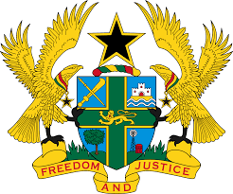

**STATEMENT BY GHANA DELIVERED BY AKOSUA D. OKYERE BADOO,**

**DEPUTY PERMANENT REPRESENTATIVE, DURING THE 44TH**

**SESSION OF THE UPR WORKING GROUP ON MONDAY, 6TH NOVEMBER 2023**

**UNIVERSAL PERIODIC REVIEW OF BURKINA FASO**

Thank you Mr. Vice President,

Ghana warmly welcomes the distinguished delegation of Burkina Faso to their 4th cycle of UPR working Group Session. We thank the delegation for their comprehensive report and extend our congratulations for their efforts in promoting and protecting human rights through the implementation of accepted recommendations in the previous cycle.

In particular, we note with appreciation the efforts made by Burkina Faso to strengthen rule of law through legislative amendments, including the National Human Rights Commission Act, and the adoption of National Gender Strategy (2019-2023).

In the spirit of constructive engagement Ghana recommends to Burkina Faso the following:

* **Consider reinstating the juvenile justice system and ensure compliance with international detention standards; and**
* **Develop a national action plan to prevent attacks and threats of attacks against educational infrastructure and the civilians, in particular children and teachers.**

We wish the delegation of Burkina Faso a successful review.

I thank you.