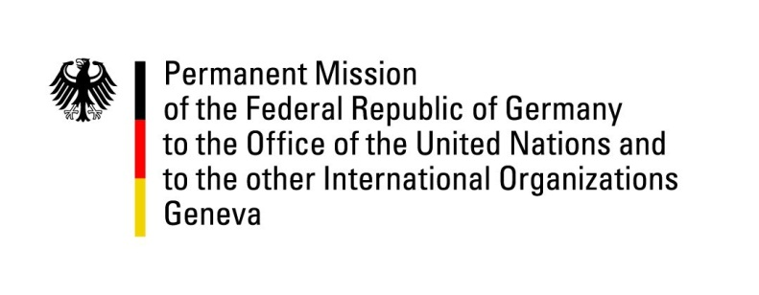

**United Nations Human Rights Council**

**44th Session of the UPR Working Group**

**Geneva, 6th of November 2023**

**German Recommendations and advance questions to**

**Burkina Faso**

Mister President,

Germany welcomes the delegation of Burkina Faso and commends the country for the abolishment of capital punishment following the last UPR. Germany commends the introduction of the Cadre de concertation, de suivi et d’alerte précoce des cas d’allégations de violations et d’abus des droits de l’homme dans la lutte anti-terroriste together with OHCHR.

However, Germany remains concerned about the increasing number of human rights violations committed by all armed groups in the fight against terrorism. Germany is deeply worried about the harassment against human rights defenders, journalists and members of the LGBTQ community. Germany also regards with concern the increasing number of rape as well as forced and early marriages accompanied by early pregnancy. Germany is worried about the limited access to justice due to closed courts and absence of judges and magistrates.

Germany therefore recommends to:

* Refrain from government interventions into the freedom of the press and freedom of expression, so that citizens and media can fully enjoy their rights.
* Fight resolutely against early and forced marriages in order to improve rights of women and girls by ensuring a minimum age of 18, and ensure broader enrolment in continued education.
* Respect human rights and international humanitarian law within the fight against terrorism. Put in place measures to protect from extrajudicial killings and torture by security forces. Reestablish access to justice by reopening courts and protecting the magistrates.

Thank you, Mister President.