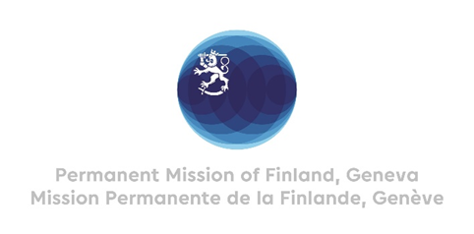

# 44 Session of the UPR working group Recommendations by Finland to Burkina Faso

# 6th November 2023

## 

Thank you Mr. President,

Finland appreciates the engagement of Burkina Faso in the UPR process and the comprehensive report presented.

Finland wishes to make the following recommendations:

1. First, to consider ratifying the Second Optional Protocol to the International Covenant on Civil and Political Rights, aiming at the abolition of the death penalty
2. Second, to consider signing and ratifying the Optional Protocol to the Convention on the Rights of the Child on individual complaints procedures
3. Third, to open a standing invitation to thematic special procedures

Finland wishes Burkina Faso every success with the follow up and implementation of the recommendations received during this fourth cycle of the UPR process.

I thank you.