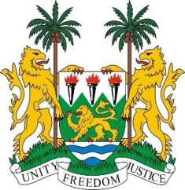

**SIERRA LEONE**

**44th Session of the UPR**

**BANGLADESH STATEMENT**

Monday, 13th November, 2023

**Mr. President**,

Sierra Leone welcomes the distinguished high-level delegation from Bangladesh and thanks it for the presentation of its national report.

Sierra Leone commends Bangladesh for its continued efforts in hosting the displaced Rohingya refugees. My delegation commends Bangladesh's cooperation with UN Special Procedures and OHCHR, particularly in facilitating ten visits by seven Special Procedures mandate holders and the UN High Commissioner for Human Rights during the reporting period.

In the spirit of constructive engagement, we recommend the following for Bangladesh`s consideration:

1. Consider ratifying the 1954 Convention relating to the Status of Stateless Persons and the 1961 Convention on the Reduction of Statelessness and adopt a national implementing legislation.
2. Consider ratifying the Convention for the Protection of All Persons from Enforced Disappearance.
3. Improve cooperation with human rights mechanisms, including the submission of outstanding reports and the acceptance of visits by special procedures, in particular the Working Group on Enforced or Involuntary Disappearances.

Sierra Leone wishes Bangladesh every success in the completion of its fourth review cycle.

Thank you, Mr. President.