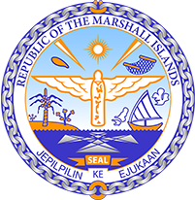

Republic of the Marshall Islands
STATEMENT by Mr. Samuel Lanwi Jnr
44th Session Universal Periodic Review
13th November 2023
Geneva

4th Cycle Review of Bangladesh

Mr. President,

The Marshall Islands welcomes the delegation of Bangladesh. We commend Bangladesh in its leadership of the Climate Vulnerable Forum and its facilitation of the visit of the Special Rapporteur on the promotion and protection of human rights in the context of climate change in September 2022.

We recommend as follows:

- Develop a clear policy strategy to deal with persons displaced by the impacts of climate change and ensure that ensuring that these strategies are formulated and implemented based on human rights.

- Strengthen protections and implement measures to mitigate the impacts of climate change on older persons.

Kommol tata and thank you Mr. President.

