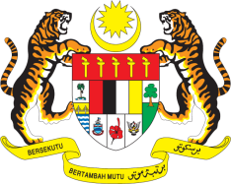

**STATEMENT BY MALAYSIA**

**REVIEW OF BANGLADESH**

**44TH SESSION OF THE UPR WORKING GROUP**

**6 – 17 NOVEMBER 2023**

Thank you Mr. President / Mr./Madam Vice President.

1. Malaysia is encouraged with Bangladesh’s progress on strengthening its judicial process. We commend Bangladesh’s significant humanitarian efforts, in sheltering over one million Rohingya refugees, despite not being a signatory to the 1951 Refugee Convention and its 1967 Protocol.
2. On this note, Malaysia further underlines two **recommendations**:
   1. First, increase efforts to strengthen protection for victims of trafficking, including by implementing a victim-centred approach; and
   2. Second, strengthen the implementation of its strategies and plans, that guarantee access to clean and safe drinking water and sanitation services, for impoverish communities, and those in rural areas.

3. We wish Bangladesh a successful review.

Thank you.

**13 NOVEMBER 2023**

**GENEVA**