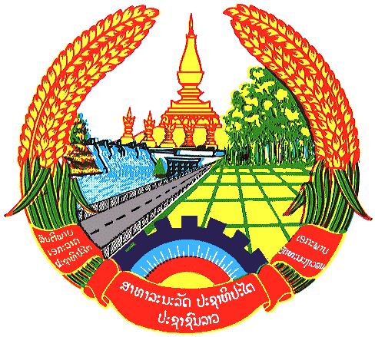

**Statement by the delegation of the Permanent Mission of the Lao PDR to the United Nations and other International Organizations in Geneva**

**at the 44th Session of UPR Working Group**

**Geneva, 13 November 2023**

Review of Bangladesh (09:00 - 12:30)

1. Thank you, Mr. President, for the floor.
2. My delegation warmly welcomes the delegation of Bangladesh and thanks for the presentation of the national report.
3. The Lao PDR commends Bangladesh’s proactive cooperation with the Human Rights Council and its mechanisms, as well as its contribution to promote international human rights. We appreciate the significant achievements made towards implementing the Sustainable Development Goals and congratulate Bangladesh on the progress in advancing gender equality.
4. The Lao PDR would like to make following recommendations:

* Continue to engage with the UN human rights mechanisms and development partners to strengthening the promotion and protection of human rights in the country.
* Continue efforts to promote women’s rights and empowerment of women to guarantee the participation of women in all sectors of the society.

1. We wish Bangladesh every success in this UPR cycle review.
2. I thank you, Mr. President.