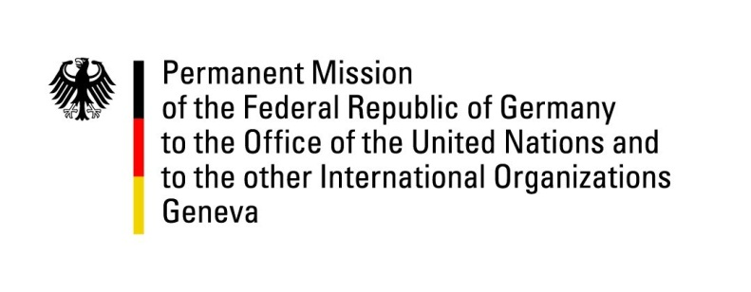

**United Nations Human Rights Council**

**44th Session of the UPR Working Group**

**Geneva, November 13, 2023**

**German Recommendations and advance questions to**

**Bangladesh**

Mister President,

Germany welcomes the delegation of Bangladesh to the fourth UPR cycle. We commend the country for its hard work on improving the working conditions in the export sector, its progress on its National Social Security Strategy, for enabling the increased participation of women in public life, protecting women and girls from violence and for its advances on the right to education.

However, Germany remains concerned about increasing limitations to freedom of expression and association. Certain provisions of the newly enacted Cyber Security Act unduly restrict freedom of expression. Germany calls on Bangladesh to ensure the full enjoyment of all liberties by all people, especially with a view to upcoming elections and civil society spaces.

Germany therefore recommends Bangladesh to

1. Ensure that the Cyber Security Act of 2023 is in full accordance with obligations under international law; and ensure swift processing or termination of all outstanding cases under the old Digital Security Act;
2. Continue to improve the situation of women and girls, *inter alia* by ensuring full equality before the law and prosecuting any sexual act without consent as sexual assault.
3. Implement the Anti-Discrimination Bill to improve protection against discrimination, in particular, on the grounds of gender, ethnicity, caste or religion.
4. Explicitly recognize indigenous people's identity and rights, especially customary land rights, in accordance with international human rights provisions such as CEDAW, ICESCR, , UNDRIP, UNDROP.

Thank you, Mister President.