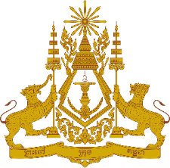

**PERMANENT MISSION OF THE KINGDOM OF CAMBODIA**

**TO THE UNITED NATIONS AT GENEVA**

**Statement of Cambodia**

At the 44th Session of the UPR Working Group

UPR of Bangladesh

13 November 2023

-------

Mr. President!

1. Cambodia warmly welcomes the distinguished delegation of Bangladesh and expresses sincere appreciation for the comprehensive presentation of the national report.
2. Cambodia commends Bangladesh for significant progress in implementing recommendations since the last UPR. We also acknowledge Bangladesh's continued engagements with UN human rights mechanisms and special procedures.
3. In the constructive spirit, Cambodia would like to put forward two recommendations:
   1. Continue to escalate efforts in preventing violence against women and children, adhering to the objectives outlined in its National Action Plan 2018-2030;
   2. Continue intensifying efforts to reduce greenhouse gas emissions.
4. Finally, I wish the delegation of Bangladesh every success in this review.

Thank you,

*\*\*\*\*\**