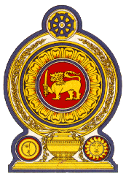

**44th Session of the Universal Periodic Review**

**Review of Azerbaijan - 14th November 2023**

**Statement by the Democratic Socialist Republic of Sri Lanka**

Mr. President,

Sri Lanka welcomes the delegation of Azerbaijan and appreciates the presentation made.

We note the inclusion of the prevention of child trafficking in the National Action Plan.

We also note the priority by Azerbaijan towards reducing maternal and child mortality and providing quality medical care for newborns.

In a constructive spirit, Sri Lanka recommends that Azerbaijan ;

1. Takes further measures to combat trafficking in persons, including child trafficking and implementation of the National Action Plan on Combating Trafficking in Persons 2020 – 2024.
2. Considers ratifying the Treaty on the Prohibition of Nuclear Weapons.
3. Takes further measures for the promotion and protection of the rights of all migrant workers and members of their families.
4. Considers allocating additional resources towards ensuring universal and equal access to primary and secondary education.

We wish Azerbaijan success in its UPR engagement.

Thank you

.