Jamhuuriyadda Federaalka Soomaaliya  Ergada Joogtada Soomaliyeed ee Qaramada Midoobey ee Geneva | 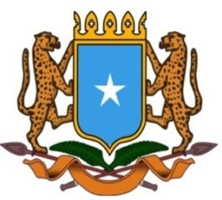 | جمهورية الصوما ل الفيدرالية  البعثة الدائمة لجمهورية الصومال بمكتب الأمم المتحدة بجنيف وبالوكالات المتخصصة بسويسرا

Permanent Mission of the Federal Republic of Somalia to the United Nations Office at Geneva and other International Organizations in Switzerland

Check Against Delivery
Statement by the Delegations of Somalia,
Mr. Hussen Abdi Musa, First Counsellor
at the Review of the Republic of Azerbaijan, during the 44th Session of the UPR Working Group on Tuesday, 14 November, 2023 from 9:00 AM to 12:30 PM, in the Room XX of the Palais des Nations in Geneva, Speaker Number 35, Time: 1 minute and 00 seconds.
Thank you Mr. President,

Somalia warmly welcomes the high level delegation of the Republic of Azerbaijan to the fourth cycle of the UPR working Group and expresses its gratitude for the presentation of their comprehensive national report. Somalia welcomes the inclusiveness and transparency of the consultation process prior to the preparation of this national report.

Somalia congratulates the government of Azerbaijan on the progress made in the implementation of the recommendations accepted during its previous report, in particular the measures taken to strengthen the institutional and normative framework for the promotion and protection of Human Rights.

Somalia encourages the government of Azerbaijan to continue its efforts to promote and protect human rights and would like to offer the following recommendations :

- Consider ratifying the Optional Protocol to the Convention on the Rights of the Child,
- consider ratifying the International Convention for the Protection of All Persons from Enforced Disappearance.

Finally, Somalia wishes Azerbaijan every success in this review.

I thank you Mr. President.

