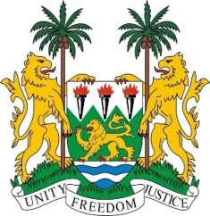

**SIERRA LEONE**

**44th Session of the UPR**

**AZERBAIJAN STATEMENT**

Tuesday, 14th November 2023

**Mr. President**,

Sierra Leone welcomes the distinguished high-level delegation of Azerbaijan and thanks it for the presentation of its national report.

We commend Azerbaijan for its continued cooperation and engagement with human rights mechanisms, including the standing invitation to all Special Procedures mandate holders. We also welcome the adoption of the Law of 7 March 2023 amending the Code of Administrative Offences to strengthen accountability for unlawful interference in the professional activities of journalists and other forms of harassment.

In a spirit of constructive engagement, we offer the following recommendations for Azerbaijan's consideration

1. Take concrete steps to decriminalise defamation and libel.
2. Consider increasing public health spending to reduce infant and maternal mortality and other preventable deaths.
3. Consider allocating more resources to education to ensure universal and equal access to quality and inclusive primary and secondary education in the country.

Sierra Leone wishes Azerbaijan every success in the completion of its fourth review cycle.

Thank you, Mr. President.