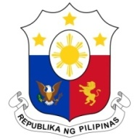 **PHILIPPINES**

**HUMAN RIGHTS COUNCIL**

**44th Session of the Working Group on the Universal Periodic Review**

14 November 2023, Palais des Nations, Geneva, Switzerland

**REVIEW OF AZERBAIJAN**

*Speaking time: 1 minute*

Thank you, Mr. Chair.

The Philippines warmly welcomes the distinguished delegation of Azerbaijan and the presentation of its national report.

The Philippines positively notes the progress achieved by Azerbaijan in advancing the Sustainable Development Goals and several legislations passed related to the promotion of social and economic rights.

In a constructive spirit, we offer the following recommendations:

1. Step up efforts to promote gender equality in the public and private sectors and to effectively combat domestic violence;
2. Further strengthen mechanisms mandated to prevent and combat human trafficking, especially investigative and judicial bodies tasked to hold perpetrators accountable before the law; and
3. Continue to enhance the conduct of mandatory and continuing human rights education and training to law enforcement officers, prosecutors and judges.

The Philippines wishes Azerbaijan a successful review. Thank you. **END**