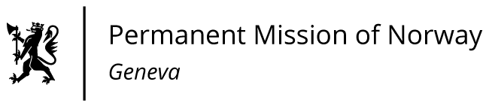

**STATEMENT**

**44th UPR Session of the Human Rights Council**

**on the human rights situation in Azerbaijan,**

**as delivered by Mr Tormod C. ENDRESEN**

**Ambassador - Permanent Representative to the UN and other International Organizations.   
The Permanent Mission of Norway in Geneva.**

Check against delivery

14 November 2023

President,

We remain deeply concerned about the human rights developments in Azerbaijan. [Since the last hearing, we have noted the additional restrictions placed on the media with particular concern.]

Norway recommends that Azerbaijan:

1. Reverse [the implementation of] the media law from 2022 to ensure [the] freedom of expression and adhere to European Council’s standards for the freedom of [expression and] the media;

2. Ensure that provisions of the Lawyers’ Code of Conduct that interfere with lawyers’ right to freedom of expression [and other human rights] are amended to adhere to international standards;

3. Immediately and unconditionally release all prisoners arrested on political grounds;

4. Secure [the] rights and fundamental freedoms of all minorities, including ethnic Armenians in Nagorno-Karabakh.  
I thank you.