*Check against delivery*

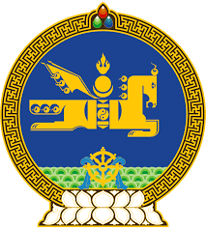

**44th SESSION OF THE UPR WORKING GROUP**

**MONGOLIA’S STATEMENT AT THE REVIEW OF THE**

**REPUBLIC OF AZERBAIJAN**

**14 November 2023**

Mongolia warmly welcomes the delegation of the Republic of Azerbaijan to the 4th cycle of the UPR process and thank them for the presentation of their national report.

Mongolia applauds Azerbaijan’s constructive engagement with the UN and regional human rights mechanisms and encourages its continuation. We commend Azerbaijan’s steadfast efforts in promoting maternal and child health including through reducing morbidity, disability and mortality among mothers and children and improving the quality of perinatal services via various programs.

Moreover, my delegation notes with appreciation Azerbaijan’s measures taken to further advance the country’s socio-economic development, and welcomes, in this regard, the adoption of important policy documents such as the “Employment Strategy for 2019-2030” and the “Strategy for the Development of Azerbaijani Youth aimed at promoting *inter alia the* effective employment and decent work for all groups of its population including youth, women and people with disabilities.

Mongolia wishes to recommend Azerbaijan the following:

* To continue its efforts to address all forms of violence against women and girls effectively, to promote gender equality and to increase women’s representation in political and public life;
* To further strengthen its Office of the Human Rights Commissioner in accordance with the Paris Principles; and
* To intensify its efforts to ratify the International Convention for the Protection of All Persons from Enforced Disappearance.

We wish the delegation of the Republic of Azerbaijan every success during this cycle of the review.

I thank you, Mr. President.

---oOo---