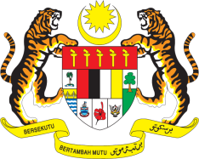

**STATEMENT BY MALAYSIA**

**REVIEW OF AZERBAIJAN**

**44TH SESSION OF THE UPR WORKING GROUP**

**6 – 17 NOVEMBER 2023**

Thank you Mr. President / Mr./Madam Vice President. Malaysia welcomes the achievements and progress that Azerbaijan has made since its third review in 2018, to improve the human rights situation in the country.

2. In the spirit of constructive engagement, Malaysia **recommends** the following:

2.1 Share its best practices in the delivery of public services with other countries through joint collaborative capacity-building programs;

2.2 Continue its efforts to eliminate corruption through implementation of its National Action Plan for Strengthening the Fight Against Corruption 2022-2026; and

2.3 Continue to safeguard rights and well-being of women especially those in rural and vulnerable communities.

3. We wish Azerbaijan a successful review.

Thank you.

**15 NOVEMBER 2023**

**GENEVA**