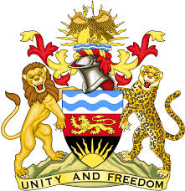

**REPUBLIC OF MALAWI**

**MALAWI STATEMENT ON THE REPUBLIC OF AZERBAIJAN UNIVERSAL PERIODIC REVIEW**

**TUESDAY, 14TH NOVEMBER 2023**

**Mr. President**,

Malawi welcomes Azerbaijan to this review and thanks the delegation for the comprehensive presentation. Malawi is honoured to be part of the Troika to Azerbaijan’s review.

Malawi commends Azerbaijan’s strides in the promotion and protection of human rights such as cooperation with the special procedures of the HRC and the commitment to her obligations under the European Convention on Human Rights.

In the spirit of constructive dialogue, Malawi makes the following recommendations to Azerbaijan:

1. Enhance the institutional capacity of Azerbaijan’s National Human Rights Institution (NHRI)
2. Continue to take all steps in combating gender-based violence.
3. Progressively adopt necessary legal and policy measures to end child marriages.

We wish the Azerbaijan all the best at this review and in the implementation of the recommendations.

**Thank you, Mr. President**.