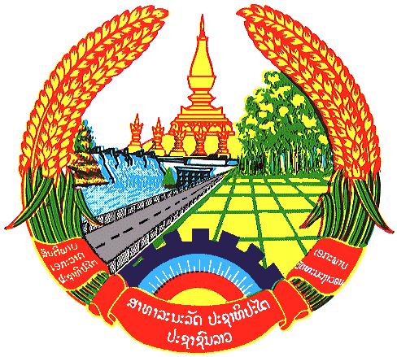

**Statement by the delegation of the Permanent Mission of the Lao PDR to the United Nations and other International Organizations in Geneva**

**at the 44th Session of UPR Working Group**

**Geneva, 14 November 2023**

Review of Azerbaijan (09:00 - 12:30)

1. Thank you, Mr. President, for the floor.
2. My delegation warmly welcomes the delegation of Azerbaijan and thanks for the presentation of the national report.
3. The Lao PDR commends Azerbaijan for taking measures to improve national legislation in compliance with international standards, which provides further protection of human rights in the country. We also welcome progress made in the promotion and protection of the human rights in the fields of education, health, women and children, among others.
4. The Lao PDR would like to make following recommendations:

* Strengthen the implementation of the national strategy and action plans on gender equality; and
* Continue to constructively cooperate with the Human Rights Council and its mechanisms to promote and protect human rights in the country and abroad.

1. We wish Azerbaijan every success in this UPR cycle review.
2. I thank you, Mr. President.