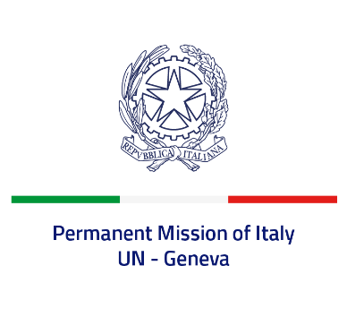

*Check against delivery*

**UPR 44 - Azerbaijan**

**Tuesday 14 November 2023, 9:00 - 12:30**

**Delivered by: Ambassador Vincenzo Grassi, Permanent Representative of Italy**

*(Focal point: Angela Zanca, First Secretary)*

Thank you, Mister President.

We thank the distinguished delegation of Azerbaijan for the presentation.

Italy recognizes the steps taken by Azerbaijan since its last UPR, in particular the adoption of amendments to the Labour Code aimed at removing legal barriers to women’s employment, as well as the improvement of the institutional and policy framework in order to advance gender equality.

Italy seizes this opportunity to offer Azerbaijan the following recommendations:

* *Further promote and protect women’s rights and consider ratifying the Council of Europe “Istanbul Convention”;*
* *Guarantee the full exercise of the rights to freedom of expression, peaceful assembly and association, to ensure an effective political pluralism;*
* *Enhance efforts to fight against all forms of discrimination;*
* *Strengthen the protection of minorities, in particular of Karabakh Armenians, creating the conditions for the voluntary, safe, dignified and sustainable return of Armenian refugees to Nagorno-Karabakh.*

We wish Azerbaijan a successful review.

I thank you.