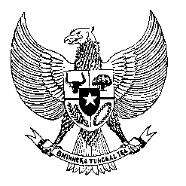

Permanent Mission

of the Republic of Indonesia to the UN, WTO,

and Other International Organizations

in Geneva

**STATEMENT BY THE DELEGATION OF THE REPUBLIC OF INDONESIA**

**AT THE 44th SESSION OF THE UPR WORKING GROUP**

**CONSIDERATION OF THE UPR REPORT OF AZERBAIJAN**

**14 NOVEMBER 2023**

**Mr. President**

Indonesia warmly welcomes the distinguished delegation of Azerbaijan and thank the delegation for their national report.

We commend Azerbaijan’s efforts to implement the recommendations given during its 3rd Cycle of UPR. We particularly applaud Azerbaijan’s efforts to invest in science and education, as it is shown by expenditure made for science and education in 2023 account for 14% of all state budget allocation.

In a constructive spirit to further support Azerbaijan in promoting and protecting human rights, Indonesia recommends:

1. Strengthen laws and regulations to improve the quality access on education and healthcare, in particular for internal displaced persons and other groups of people in vulnerable situations.
2. Continue working together with civil society organizations and other related stakeholders to develop capacities of government officials, at national and local levels.
3. Further implementing a whole-of-society approach to its policies on combating trafficking in persons.

Thank you.

*Word Count: 147 words*

*Max. Speaking Time: 1 minute*