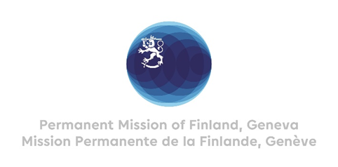

**44 Session of the UPR working group**

**Recommendations by Finland to Azerbaijan**

**14th November 2023**

Mr. President,

Finland welcomes the engagement of Azerbaijan in the UPR.

Finland recommends the following:

1. First, take effective preventive measures to combat violence against women as well as domestic violence and provide adequate and sufficient support to victims, including shelters.

1. Second, guarantee freedom of expression, access to information and plurality of the media.
2. Third, protect the right of human rights defenders and journalists to undertake their legitimate work without harassment, intimidation or reprisals.

1. Fourth, guarantee the independence and impartiality of the judiciary and strengthen the criminal justice system, including by improving the execution of the judgements of the European Court of Human Rights.

We wish Azerbaijan a successful UPR review.

Thank you.