***Check Against Delivery***

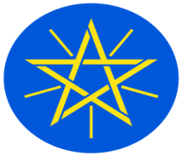

**Statement**

**by**

**the Representative of the Federal Democratic Republic of Ethiopia on the Universal Periodic Review of** **Azerbaijan**

**14 November, 2023**

***Mr. President,***

Ethiopia warmly welcomes the delegation of **Azerbaijan** to the 44th Session of the UPR Working Group. We thank the delegation for its comprehensive national report and the oral update today.

Ethiopia commends **Azerbaijan** for implementing the recommendations received during previous UPR cycles, and for adoption of several laws to strengthen the promotion and protection of human rights.

In a sprite of constructive dialogue, Ethiopia recommends to **Azerbaijan** to continue:

1. further strengthening its institutional framework with a view to respect of human rights,
2. its cooperation with human rights bodies and mechanisms at both the regional and international levels, and
3. to build and improve health-care infrastructure in rural and remote areas.

Finally, Ethiopia wishes success to the delegation of **Azerbaijan** in its engagement with the UPR Working Group.

***I thank you.***