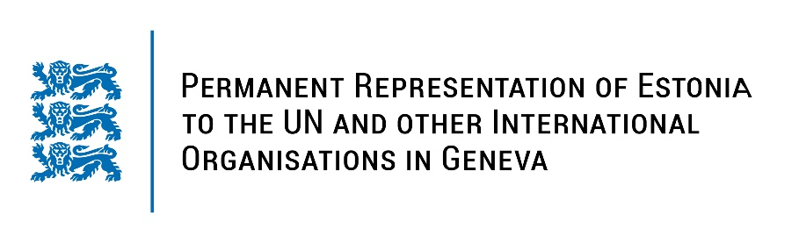

**Universal Periodic Review of Azerbaijan**

**14 November 2023**

**Intervention by the delegation of Estonia**

Estonia welcomes the delegation of Azerbaijan to its fourth UPR and thanks for the presentation today.

Estonia welcomes the steps taken by the government to improve economic and social rights of its citizens. We appreciate the measures taken to combat domestic violence and to reduce gender inequality, but remain concerned about the high incidence of gender-based violence and about the persistence of discriminatory stereotypes in the society.

We recommend Azerbaijan to:

- sign and ratify the Council of Europe Convention on preventing and combating violence against women and domestic violence;

- adopt and implement the law and the national strategy on reproductive health and family planning, including by providing a comprehensive sexuality education curriculum in schools;

- adopt legislation to explicitly prohibit and prevent corporal punishment in all settings, in particular at the home, schools, day care and alternative care settings;

- protect and promote the freedom of opinion and expression and media freedom and ensure that the relevant legislation is in line with international standards.

We wish Azerbaijan a successful review.

Thank you.