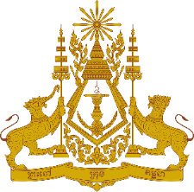

**PERMANENT MISSION OF THE KINGDOM OF CAMBODIA**

**TO THE UNITED NATIONS AT GENEVA**

**Statement of Cambodia**

At the 44th Session of the UPR Working Group

UPR of the Republic of Azerbaijan

14 November 2023

-------

Mr. President!

1. Cambodia warmly welcomes the distinguished delegation of the Republic of Azerbaijan and appreciate the very comprehensive national report presented.
2. We commend the progress made by Azerbaijan authorities in implementing recommendations since the last UPR. Cambodia sincerely congratulates Azerbaijan for remarkable progress in social development, education, gender equality and the rights of vulnerable groups.
3. In the constructive spirit, Cambodia would like to put forward two recommendations:
   1. Continue to promote economic and social development in accordance with the National Priority of Socio-Economic Development 2030;
   2. Continue its efforts to promote, protect, and realize the right to education for all as a national priority.
4. Finally, I wish the delegation of Azerbaijan every success in this review.

Thank you,

*\*\*\*\*\**