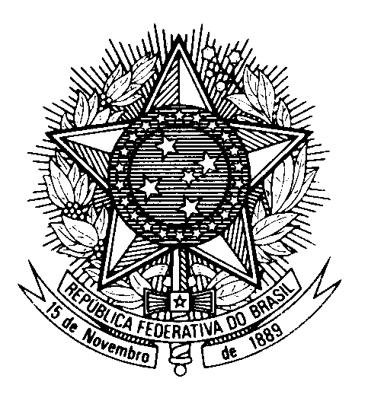

Review of Azerbaijan during the

44th session of the Working Group on the Universal Periodic Review Statement of Brazil

(Geneva, 14 November 2023)

Thank you, Mr. President.

Brazil welcomes the delegation of Azerbaijan to the fourth cycle of the UPR.

We commend the implementation of the "Inclusive Education" programme, with a view to promote quality inclusive education for children with disabilities. We note the measures taken to facilitate the teaching of minority languages and encourage the adoption of policies to promote the expression of the cultural identities of minorities.

In a constructive spirit, Brazil would like to recommend Azerbaijan to:

1) Develop gender equality public policies to improve women's access to more qualified jobs and reduce gender pay gaps.

2) Develop social security mechanisms, especially for low-income families, including pensions and programmes to improve the living conditions of retired workers.

We wish Azerbaijan success in its review.

Thank you.

