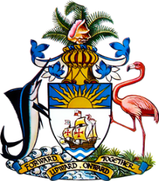

**Statement by Second Secretary Mr. Charles Gibson of the Permanent Mission of The Bahamas to the United Nations Office and other International Organizations in Geneva**

**at the 44th Session of the Universal Periodic Review Working Group**

***Presentation of UPR Report by the Government of Azerbaijan* 14November 2023**

Thank you, Madam Vice-President,

The Bahamas thanks the delegation of Azerbaijan for its report and commends progress made since the last review.

Azerbaijan has advanced efforts in human rights, notably by establishing the Association of Rural Women in 2019 to aid rural women's social and economic growth. We also positively acknowledge collaboration by Azerbaijan with UNHCR on refugee and asylum seeker issues.

In a constructive spirit, The Bahamas recommends that Azerbaijan:

1. Ensure access to quality health care and education for children with disabilities.
2. Takes concrete steps to assess the effects on children’s health of polluted air, water and soil.
3. Ensure access for rural women and girls to education, employment opportunities and health care.

We wish Azerbaijan a successful UPR.

I thank you.