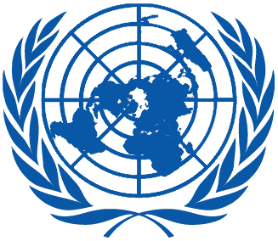 | Working Group on the Universal Periodic Review
Fortieth session
Geneva, 24 January–4 February 2022

Order of the Day
Plenary Meetings – Room XX
Tuesday, 1 February 2022
MORNING
9:00 – 12:30  13th meeting |  | UPR of Sudan  - National Report of Sudan in accordance with paragraph 15 (a) of the annex to HRC resolution 5/1 and paragraph 5 of the annex to HRC resolution 16/21: A/HRC/WG.6/39/SDN/1  - Compilation prepared by the OHCHR in accordance with paragraph 15 (b) of the annex to HRC resolution 5/1 and paragraph 5 of the annex to HRC resolution 16/21: A/HRC/WG.6/39/SDN/2  - Summary prepared by the OHCHR in accordance with paragraph 15 (c) of the annex to HRC resolution 5/1 and paragraph 5 of the annex to HRC resolution 16/21: A/HRC/WG.6/39/SDN/3
AFTERNOON  16:00 – 18:00  14th meeting |  | Adoption of the recommendations section on:  Lithuania  - Draft report of the UPR Working Group: A/HRC/WG.6/40/L.6  Uganda  - Draft report of the UPR Working Group: A/HRC/WG.6/40/L.7  Timor-Leste  - Draft report of the UPR Working Group: A/HRC/WG.6/40/L.8  Republic of Moldova  - Draft report of the UPR Working Group: A/HRC/WG.6/40/L.9
Notes:
All speakers scheduled to take the floor should upload the written version of their oral statements through the online system for inscription on the lists of speakers (https://uprreg.ohchr.org/) before the opening of the review.
- The full text of statements is available on UPR extranet page
- Identity photo-badges valid for the session may be obtained by all delegations, if needed, from the UNOG Security and Safety Section at the “Pregny Gate” (Palais des Nations, 8-14 avenue de la Paix) from 8.00 a.m. to 5.00 p.m. upon presentation of a copy of their letter of accreditation and an identity document.
- PHOTOGRAPHS AND FILMING: Please note that only accredited media are permitted to film and take photographs in Room XX.

