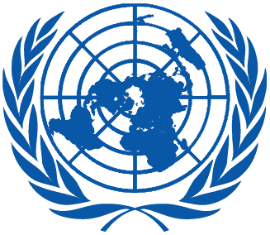 | Working Group on the Universal Periodic Review
Thirty-eighth session
Geneva, 3–14 May 2021

Order of the Day
Plenary Meetings – Assembly Hall
Friday, 14 May 2021
AFTERNOON
15:30 – 18:00  17th meeting |  | Adoption of the recommendations section on:
Solomon Islands
– Draft report of the UPR Working Group: A/HRC/WG.6/38/L.10
Seychelles
– Draft report of the UPR Working Group: A/HRC/WG.6/38/L.11
Latvia
– Draft report of the UPR Working Group: A/HRC/WG.6/38/L.12
Singapore
– Draft report of the UPR Working Group: A/HRC/WG.6/38/L.13
Sierra Leone
– Draft report of the UPR Working Group: A/HRC/WG.6/38/L.14
Notes:
All speakers scheduled to take the floor should upload the written version of their oral statements through the online system for inscription on the lists of speakers (https://uprreg.ohchr.org/) before the opening of the review
- The full text of statements is available on UPR extranet page
- Identity photo-badges valid for the session may be obtained by all delegations, if needed, from the UNOG Security and Safety Section at the “Pregny Gate” (Palais des Nations, 8-14 avenue de la Paix) from 8.00 a.m. to 5.00 p.m. upon presentation of a copy of their letter of accreditation and an identity document.
- PHOTOGRAPHS AND FILMING: Please note that only accredited media are permitted to film and take photographs in the Assembly Hall.

