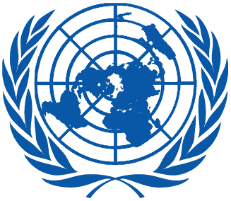 | Working Group on the Universal Periodic Review
Thirty-sixth session
Geneva, 2–13 November 2020

Order of the Day
Plenary Meetings – Assembly Hall
Wednesday, 4 November 2020
MORNING
9:00 – 12:30  4th meeting |  | UPR of Mongolia  - National report of Mongolia: A/HRC/WG.6/36/MNG/1  - Compilation prepared by the OHCHR in accordance with paragraph 15 (b) of the annex to HRC resolution 5/1 and paragraph 5 of the annex to HRC resolution 16/21: A/HRC/WG.6/36/MNG/2  - Summary prepared by the OHCHR in accordance with paragraph 15 (c) of the annex to HRC resolution 5/1 and paragraph 5 of the annex to HRC resolution 16/21: A/HRC/WG.6/36/MNG/3
AFTERNOON
14:30 – 18:00  5th meeting |  | UPR of Maldives  - National report of Maldives: A/HRC/WG.6/36/MDV/1  - Compilation prepared by the OHCHR in accordance with paragraph 15 (b) of the annex to HRC resolution 5/1 and paragraph 5 of the annex to HRC resolution 16/21: A/HRC/WG.6/36/MDV/2  - Summary prepared by the OHCHR in accordance with paragraph 15 (c) of the annex to HRC resolution 5/1 and paragraph 5 of the annex to HRC resolution 16/21: A/HRC/WG.6/36/MDV/3
IMPORTANT - UPR 36: As of 3 November 2020, in-person participation at UPR reviews is strictly limited. Delegations are therefore strongly encouraged to deliver their statements via pre-recorded video messages. Alternatively, delegations will have the possibility to deliver their statements live via Zoom (a Zoom link will be shared with all delegations on the list of speakers as soon as possible). Only those delegations who are unable to pre-record video messages or participate via Zoom can exceptionally deliver their statements from the Palais des Nations and are invited to get in touch with the UPR Secretariat at uprstates@ohchr.org in order to make the necessary arrangements.
Notes:
All speakers scheduled to take the floor should upload the written version of their oral statements through the online system for inscription on the lists of speakers (https://uprreg.ohchr.org/) before the opening of the review.
- The full text of statements is available on UPR extranet page
- Identity photo-badges valid for the session may be obtained by all delegations, if needed, from the UNOG Security and Safety Section at the “Pregny Gate” (Palais des Nations, 8-14 avenue de la Paix) from 8.00 a.m. to 5.00 p.m. upon presentation of a copy of their letter of accreditation and an identity document.
- PHOTOGRAPHS AND FILMING: Please note that only accredited media are permitted to film and take photographs in Room XX.

