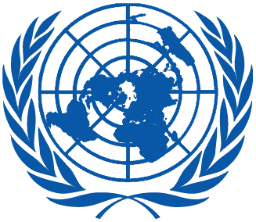 | Working Group on the Universal Periodic Review
Thirtieth session
Geneva, 7–18 May 2018

Order of the Day
Plenary Meetings – Room XX
Friday, 18 May 2018
AFTERNOON
17:00 – 18:00 *  18th meeting |  | Adoption of the recommendations section on:
Cameroon
– Draft report of the UPR Working Group: A/HRC/WG.6/30/L.13
 |  | Cuba
 |  | – Draft report of the UPR Working Group: A/HRC/WG.6/30/L.14
Notes:
All speakers scheduled to take the floor should provide the Secretariat beforehand with copies of the statements.
- The full text of statements is available on UPR extranet page
- Identity photo-badges valid for the session may be obtained by all delegations, if needed, from the UNOG Security and Safety Section at the “Pregny Gate” (Palais des Nations, 8-14 avenue de la Paix) from 8.00 a.m. to 5.00 p.m. upon presentation of a copy of their letter of accreditation and an identity document.
- PHOTOGRAPHS AND FILMING: Please note that only accredited media are permitted to film and take photographs in Room XX.

* The Working Group on the Universal Periodic Review will resume immediately after the closure of the 28th special session of the Human Rights Council.

