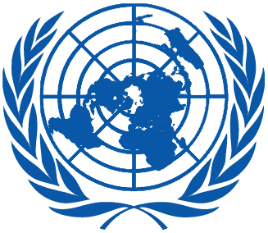 | Working Group on the Universal Periodic Review
Twenty-ninth session
Geneva, 15–26 January 2018

Order of the Day
Plenary Meetings – Room XX
Tuesday, 23 January 2018
MORNING
9:00 – 12:30  13th meeting |  | UPR of Israel  - National report of Israel: A/HRC/WG.6/29/ISR/1  - Compilation prepared by the OHCHR in accordance with paragraph 15 (b) of the annex to HRC resolution 5/1 and paragraph 5 of the annex to HRC resolution 16/21: A/HRC/WG.6/29/ISR/2  - Summary prepared by the OHCHR in accordance with paragraph 15 (c) of the annex to HRC resolution 5/1 and paragraph 5 of the annex to HRC resolution 16/21: A/HRC/WG.6/29/ISR/3
AFTERNOON  16:30 – 18:00  14th meeting |  | Adoption of the recommendations section on:  Burundi  - Draft report of the UPR Working Group: A/HRC/WG.6/29/L.7  Luxembourg  - Draft report of the UPR Working Group: A/HRC/WG.6/29/L.8  Barbados  - Draft report of the UPR Working Group: A/HRC/WG.6/29/L.9
Notes:
All speakers scheduled to take the floor should provide the Secretariat beforehand with copies of the statements.
- The full text of statements is available: UPR extranet page
- Identity photo-badges valid for the session may be obtained by all delegations, if needed, from the UNOG Security and Safety Section at the “Pregny Gate” (Palais des Nations, 8-14 avenue de la Paix) from 8.00 a.m. to 5.00 p.m. upon presentation of a copy of their letter of accreditation and an identity document.
- PHOTOGRAPHS AND FILMING: Please note that only accredited media are permitted to film and take photographs in Room XX.

