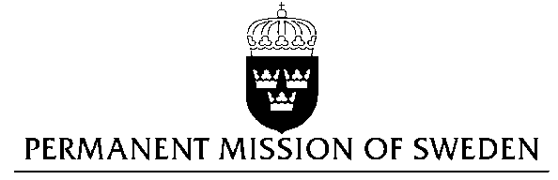
UN Human Rights Council

UPR 27th session

Statement by Sweden in the interactive dialogue on the United Kingdom

1 min 10 secs

Mr President,

Sweden wishes to welcome the delegation of the United Kingdom.

Sweden recommends the Government of the United Kingdom:

- To ban corporal punishment of children to ensure the full protection and freedom from violence of all children.

- To ensure that the law governing access to abortion in Northern Ireland fully complies with international human rights law, by decriminalizing abortion and ensuring access to abortion in cases of severe and fatal fetal anomalies and where the pregnancy is a result of rape or incest.

In the previous UPR, the United Kingdom received many recommendations on its policy regarding child protection. The United Kingdom has not yet acted on these recommendations. Almost one fifth of the population of16-59 year olds in the United Kingdom are estimated to have been subject to physical harm at home during their youth.

The 1967 abortion Act, which legalizes abortions up to 24 weeks’ pregnancy, does not apply in Northern Ireland. There, abortion is only legal when the life of the mother is at risk. It is perceived as a criminal offence if performed otherwise. There were reportedly only 16 terminations of pregnancy in hospitals in Northern Ireland in 2014-2015. Since women from Northern Ireland are not entitled to free abortions in England, and must fund the cost of the procedure from their own pocket, this disproportionately affects the poorest women.

I thank you Mr. President

