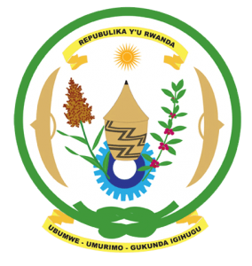
27th Session of the Universal Periodic Review Working Group
Review of the United Kingdom
04th May 2017

Statement by Rwanda delivered by Mr. Moses Rugema
Thank you Mr. President,
- Rwanda welcomes the delegation of the United Kingdom and thanks them for the presentation of their third cycle national report and the update just provided.
- Rwanda welcomes the United Kingdom’s efforts to combat violence against women and girls including through legislative and policy measures to address domestic and intimate partner violence.
- We welcome the United Kingdom’s efforts to combat discrimination in all forms and in that regard, we have one question and one recommendation:

- As part of its efforts to combat discrimination, has the United Kingdom undertaken an assessment or analysis of potential risk factors of atrocity crimes with a view to their prevention?
- We recommend that the United Kingdom consider including in its next UPR report, information on measures it has taken to analyse potential risk factors of atrocity crimes including through utilising the UN Framework of Analysis for Atrocity Crimes.
We wish the United Kingdom every success in the implementation of the recommendations of this UPR.
Thank you

