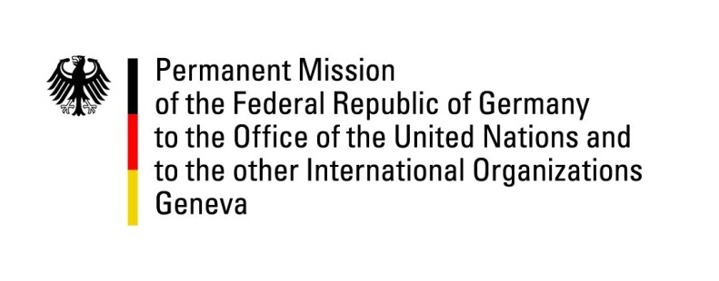

United Nations Human Rights Council
27th Session of the UPR Working Group

Geneva, 4 May 2017
---
German recommendations
to
the United Kingdom of Great Britain and Northern Ireland
Mr. President,

Germany warmly welcomes the delegation of the United Kingdom of Great Britain and Northern Ireland to the UPR and commends it for its continuous commitment to the promotion and protection of Human Rights nationally as well as internationally. We particularly welcome the lively public discourse in the United Kingdom of Great Britain and Northern Ireland on ongoing challenges, including solicitation of active participation of civil society in the UPR process which we consider vital for generating genuine progress.

Germany would like to offer the following recommendations:
- Ratify the International Convention for the Protection of All Persons from Enforced Disappearance (CPED).
- Introduce a general time limit on immigration detention and ensure such detention is not used in the case of vulnerable individuals and groups.

Questions submitted in advance:
- Can the United Kingdom of Great Britain and Northern Ireland confirm it will not dilute the existing protections by the Human Rights Act 1998 if it goes ahead with proposals for a British Bill of Rights?
- Will the Government remain committed to retaining membership of the Council of Europe and to maintaining the current level of protection for human rights within the United Kingdom of Great Britain and Northern Ireland and consider how international human rights commitments can be further strengthened within the domestic legal system?

