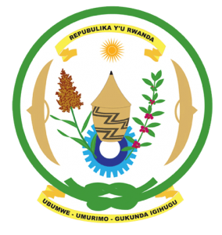
27th Session of the Universal Periodic Review Working Group
Review of Tunisia
02nd May 2017
Statement by Rwanda delivered by H.E. Francois Xavier Ngarambe
Ambassador and Permanent Representative
Thank you Mr. President,
- Rwanda warmly welcomes the delegation of Tunisia and thanks them for the presentation of their national report.
- Rwanda welcomes Tunisia’s continued efforts to promote and protect human rights, promote the rule of law and consolidate the democratic process particularly through the adoption of its 2014 Constitution and the various institutional reforms that have been undertaken.
- Rwanda commends Tunisia for the notable progress it has registered in improving the social and economic status of its citizens.

Rwanda has the following recommendations:

That Tunisia:
- Work toward eliminating any loopholes in national legislation that might undermine the protection of women’s rights and the principle of gender equality including on domestic violence and marital rape.
- Maintains its de facto moratorium on the use of the death penalty with a view towards its total abolition.
We wish Tunisia every success in the implementation of the recommendations of this UPR. Thank you

